- This top section needs changed to something like below (including the content). Obviously, this is from AI so we need to make it more personalised and real. Keep the CTAs.
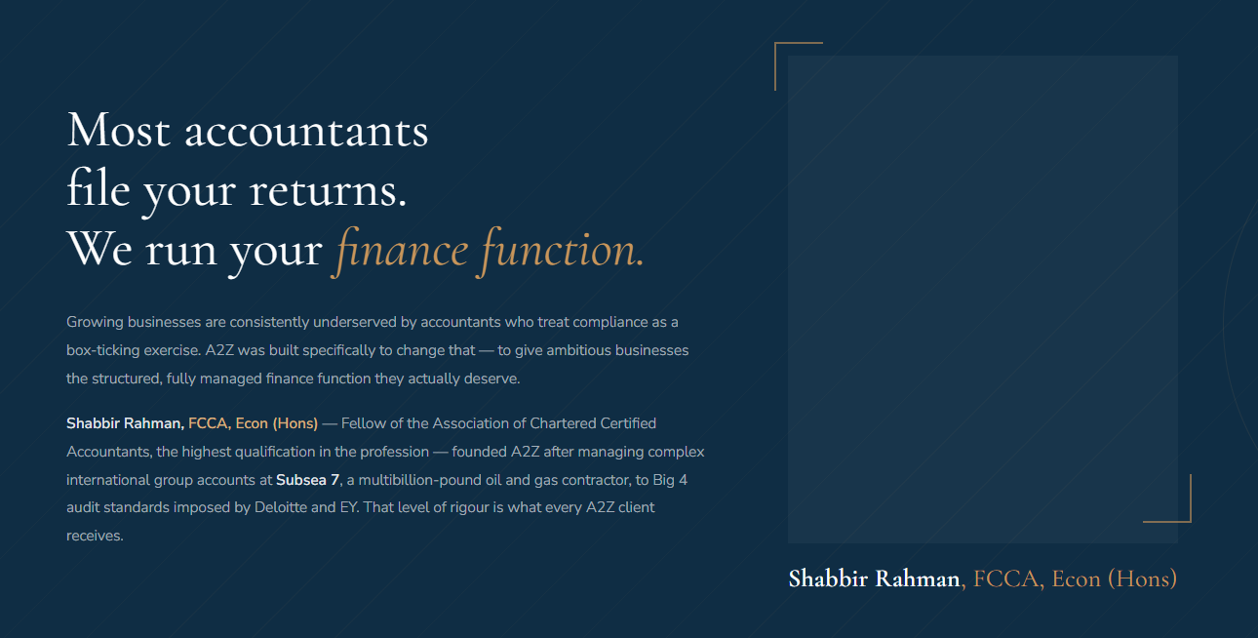
The below section needs to be presented after Founder section (but improve the design, and font style and background – this is just my idea):
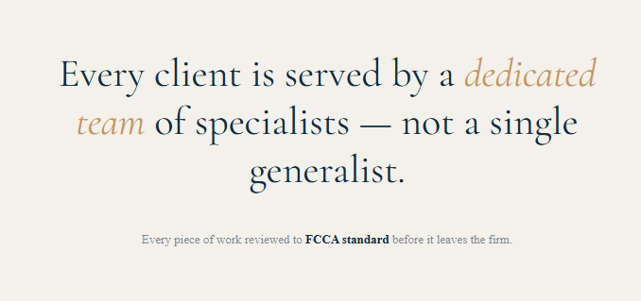

- Remove this section
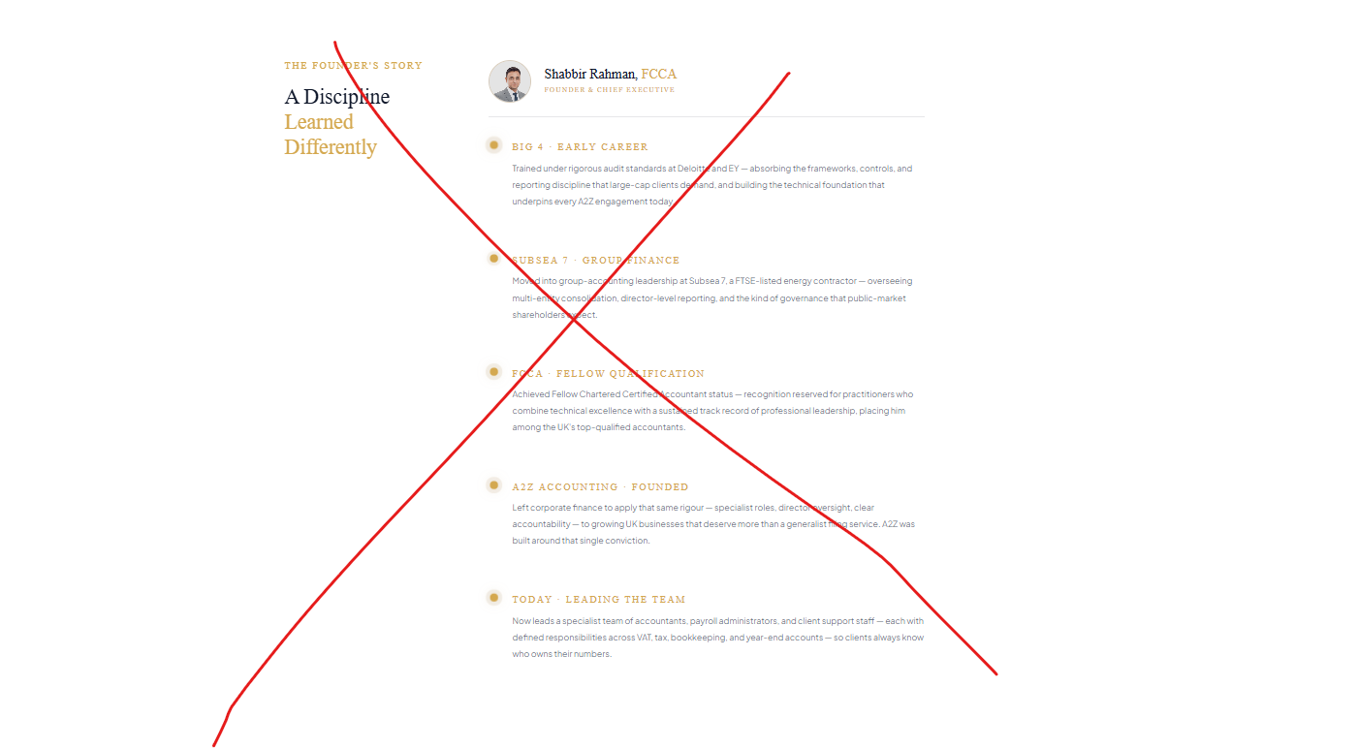
- Redo the next section like this
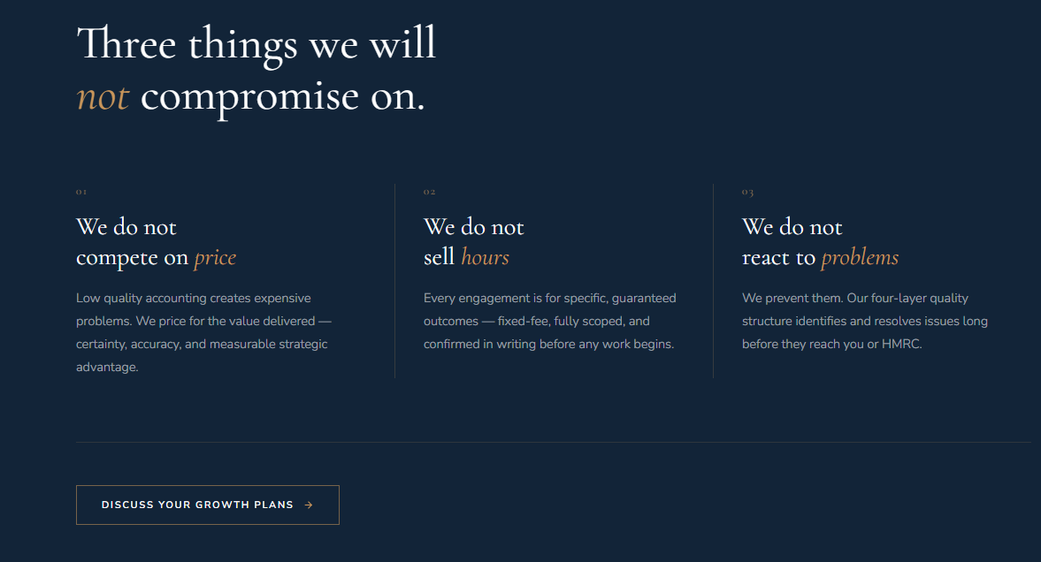

- Remove this part
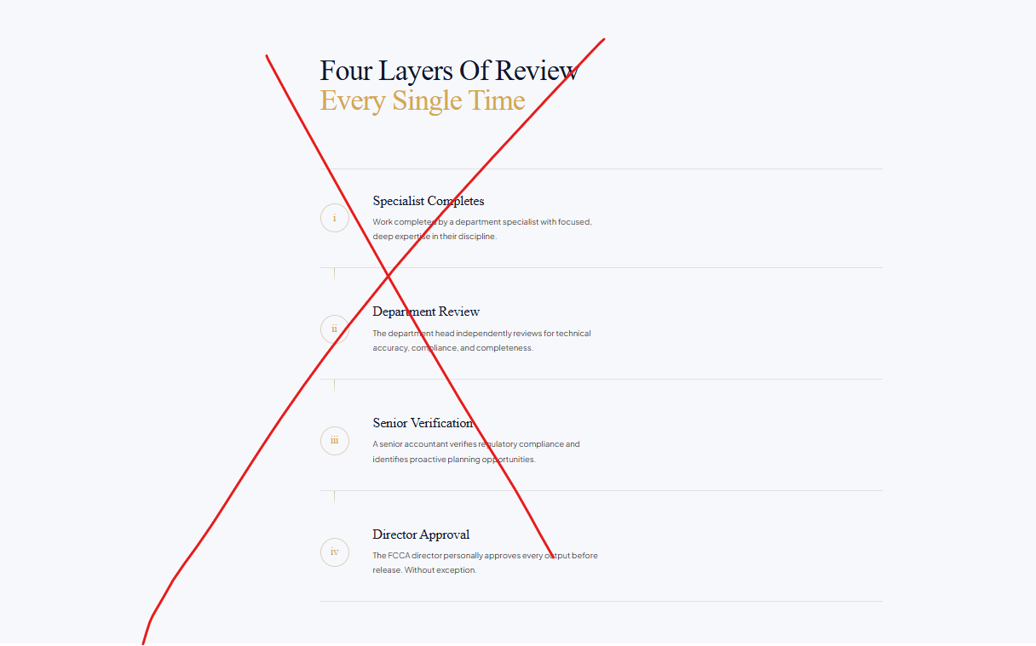
- I think this section should be redesigned nicer and presented towards the top of the page
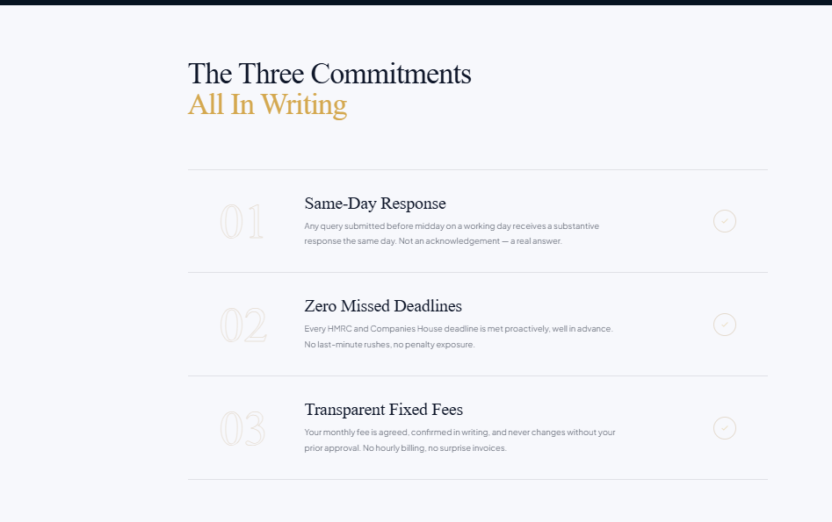
- This section looks messy, unclear and there is no trust badge. Anyone can claim that this was from a client when it was not so if this was on Google, need google icon on each one.
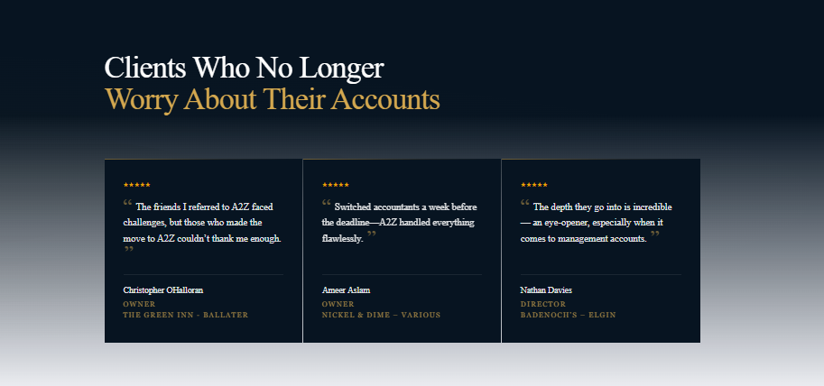
- Remove the crossed part
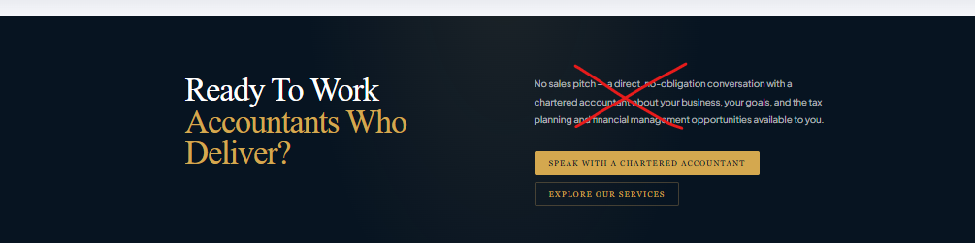

- Move the part up shown by an arrow and the circled part has font size too large
